Final Project of DSP Lab
By Mo Qin and Jincheng Tian

Unfortunately, we did not notice that we are not supposed to make the voice controlling game right before we finish the first version of the project, which is a voice control of the Sokoban game (boxes pushing game). Therefore, we decided to change to another project, which is an automatic-response robot.

We learned how to process audio files in this class. In the project, we tried to make a robot that could recognize speech and then respond to it. Because there are many old people who have no one to talk to, our original intention is to make a robot to accompany them. We set the robot as a little girl named Bingbing who can answer some simple questions. We only tried to do a few short questions because we didn't have enough time. The question and answers base is attached in the end of this document.

To implement the voice recognition question response robot, we first create a chat page, which used Vue. When clicking record, call the redcord.js to collect the microphone sound, and transfer the collected sound data to the API /audio interface built by Django as the back-end. so that we could use python to deal with voice recognition. In order to let the code recognize our voice input, we use speech_recognition package(Open source).

Speech recognition, as the name suggests, refers to automatic recognition of human speech. Speech recognition is one of the most important tasks in the domain of human computer interaction. If you have ever interacted with Alexa or have ever ordered Siri to complete a task, you have already experienced the power of speech recognition. Speech recognition has various applications ranging from automatic transcription of speech data (like voicemails) to interacting with robots via speech.

Call speech_recognition to identify the converted audio output and send it back to the front end, which displays the converted audio output and passes the recognition to the back-end API/Reply, which uses the TFIDF text similarity algorithm to compare the problem with thequestion and answers base in data.py. Returns the answer to the question that best fits

Here are some code screenshot and the running result of our project.

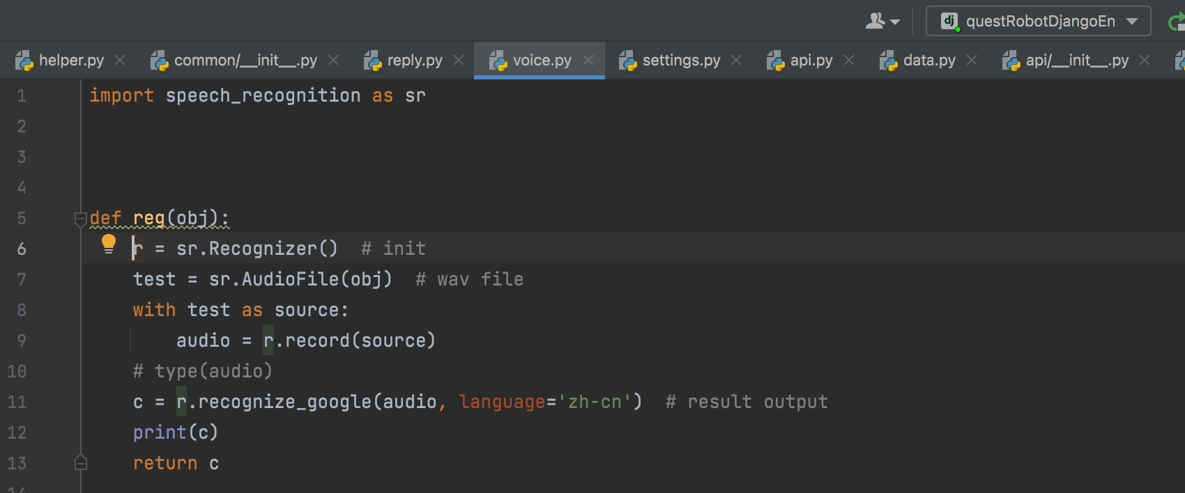

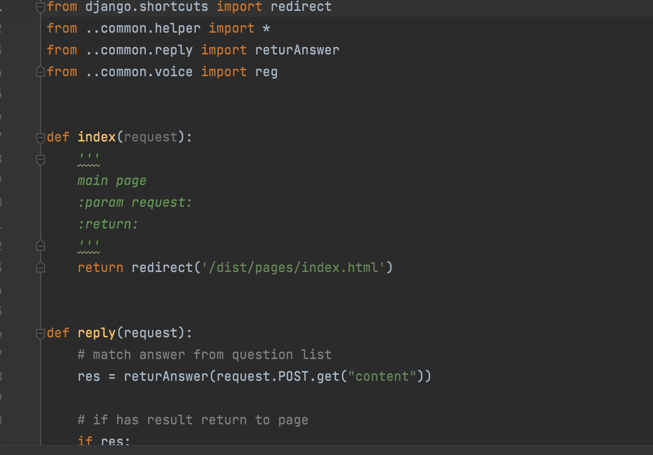

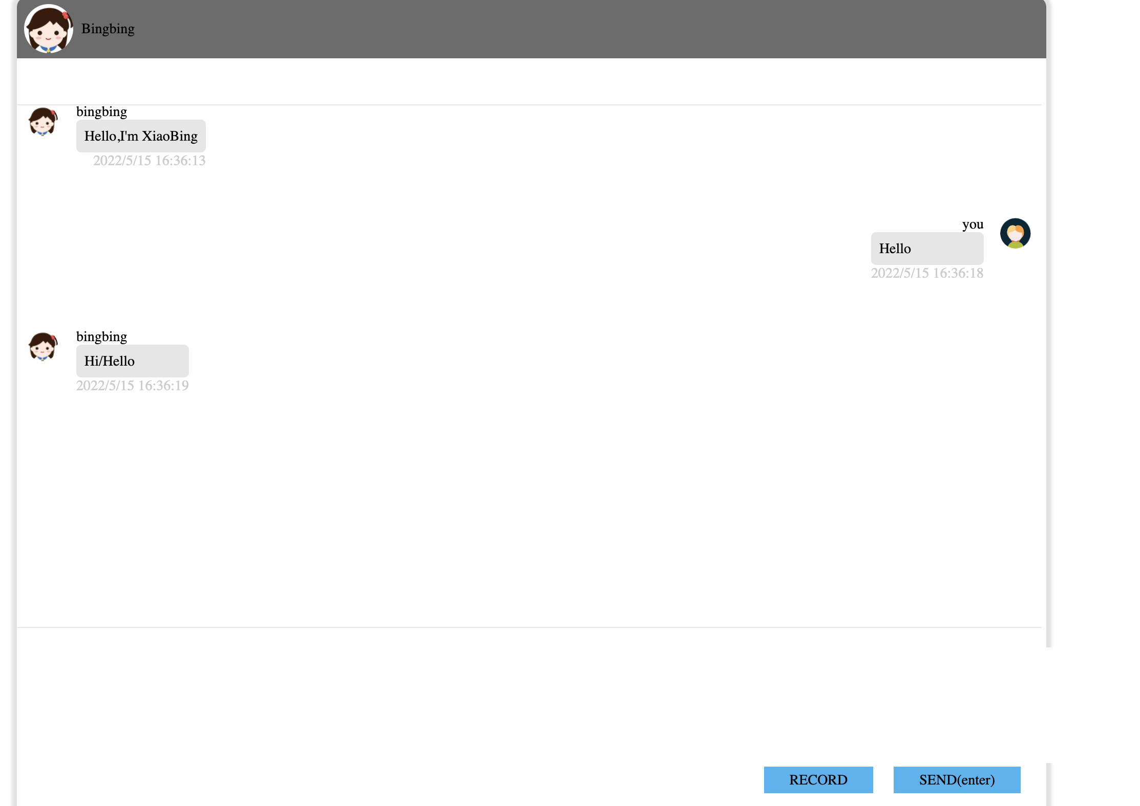

Question and answers we have now:
Hello/Hi
Hi/Hello

Who is this?
I am your friend

Who are you?
I am your friend

Nice to meet you
Nice to meet you too

How are you?
Good, thank you!

How is the weather？
it is sunny

What is your name?
My name is Project

Where are you from?
I’m from DSP Lab

How old are you?
I’m 0 year old

